Batch: A2 Roll No.: 16010122034

Experiment No.6

TITLE: Implementation of LRU Page Replacement Algorithm.

AIM: The LRU algorithm replaces the least recently used that is the last accessed memory block from user.
______________________________________________________________________
Expected OUTCOME of Experiment: (Mention CO/CO’s attained here)
CO3- Learn and evaluate memory organization and cache structure
CO2- Understand the Central processing unit with addressing modes and working of control
unit in depth
___________________________________________________________________
Books/ Journals/ Websites referred:
- Carl Hamacher, Zvonko Vranesic and Safwat Zaky, “Computer Organization”, Fifth Edition, TataMcGraw-Hill.
- William Stallings, “Computer Organization and Architecture: Designing for Performance”, Eighth Edition, Pearson.
_____________________________________________________________________
Pre Lab/ Prior Concepts:

It follows a simple logic, while replacing it will replace that page which has least recently used out of all.
a) A hit is said to be occurred when a memory location requested is already in the cache.
b) When cache is not full, the number of blocks is added.
c) When cache is full, the block is replaced which is recently used
Algorithm:
- Start
- Get input as memory block to be added to cache
- Consider an element of the array
- If cache is not full, add element to the cache array
- If cache is full, check if element is already present
- If it is hit is incremented
- If not, element is added to cache removing least recently used element
- Repeat step 3 to 7 for remaining elements
- Display the cache at very instance of step 8
- Print hit ratio
- End

Example:

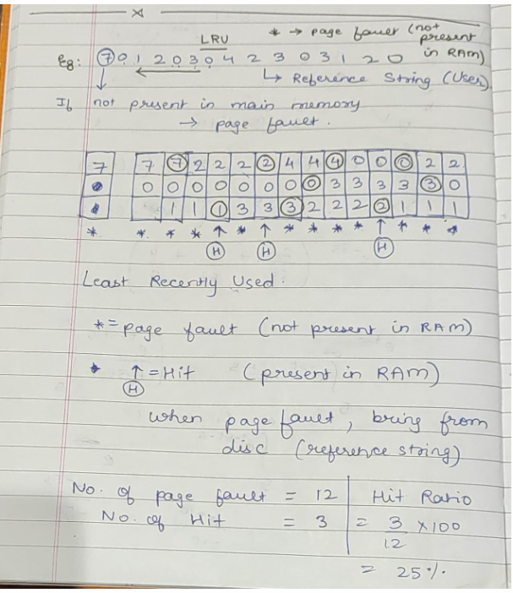
CODE:
nums = input().split()
ram = [None, None, None]
recency = [0, 1, 2]
for num in nums:
print()
if num not in ram:
print("Fault.")
index = recency.index(0)
ram[index] = num
for i in range(3):
if i == index:
recency[i] = 2
elif recency[i]:
recency[i] -= 1
else:
print("Hit.")
index = ram.index(num)
for i in range(3):
if i == index:
recency[i] = 2
elif recency[i]:
recency[i] -= 1
print(ram)

OUTPUT
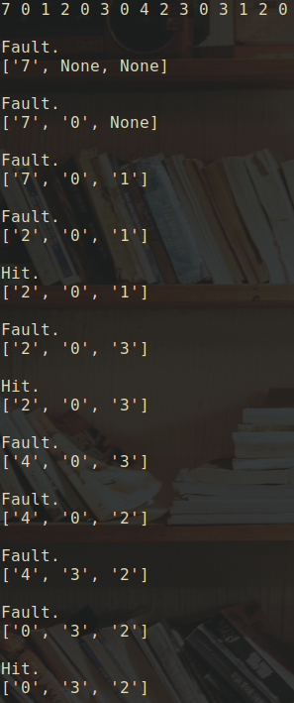
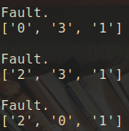

Post Lab Descriptive Questions

1. Define hit rate and miss ratio?
The hit rate, often expressed as a percentage, measures the proportion of memory accesses that result in a cache hit. A cache hit occurs when the requested data is found in the cache, so there's no need to access the main memory or external storage. High hit rates are desirable because they indicate that a significant portion of memory accesses are satisfied by the cache, reducing the overall memory access time.

The miss ratio, also expressed as a percentage, measures the proportion of memory accesses that result in a cache miss. A cache miss occurs when the requested data is not found in the cache, necessitating a retrieval from the main memory or external storage. High miss ratios indicate that a large number of memory accesses are not served by the cache and must access slower memory levels.

2. What is the need for virtual memory?
virtual memory is needed in computer systems for the following key reasons:

- It allows computers to use more memory than physically available.
- It isolates processes, enhancing security and stability.
- It simplifies memory management for software development.
- It optimizes the use of physical memory.
- It enables efficient handling of large files.
- It supports multitasking and concurrent processes.
- It helps protect the system from crashes due to memory issues.

Conclusion
Hence the Least Recently Used algorithm was learnt and encoded accordingly.
Date: _____________

